Template of Manuscript in BISC 2024, SPIE proceedings manuscript sample (A4 size)

S. Gregory Jones*ª, Titania A. R. Schmidt^{b}, Kenneth M. Suzukiª
ªNation’s Research Laboratory, 345 Photon Drive, Los Angeles, CA, USA 95555-0345; ^{b}Dept. of Optics, Central Univ./City Branch, 9876 Light Ave., Philadelphia, PA USA 00555-9642

Abstract
From BISC2024, the SPIE format will be used for BISC2024 proceedings. Therefore, a minimum of 2 pages and a maximum of 12 pages are mandatory required. Manuscripts accepted for the BISC2024 proceedings will be published in the OPIC Technical Digest and may also be submitted for inclusion in the SPIE Digital Library. Those who wish to publish their manuscripts in the SPIE Digital Library must submit the manuscript accepted for BISC2024 proceedings through SPIE submission site. Information will be noticed in the acceptance email from OPIC around early February 2024.
Begin the abstract two lines below author names and addresses. The abstract summarizes key findings in the paper in 250 words or less. For the keywords, select up to 8 key terms for a search on your manuscript's subject.

Keywords: Times Roman, image area, acronyms, references

INTRODUCTION

Margins
If the paper does not have the margins shown in Table 1, it will not upload properly.
Table 1. Margins and print area specifications.
PAPER MARGINS
A4 Letter
Top margin 2.54 cm (1in.) Top margin 1.0 in. (2.54 cm)
Bottom margin 4.94 cm (1.95 in.) Bottom margin 1.25 in. (3.17 cm)
Left, right margin 1.925 cm (.76 in.) Left, right margin .875 in. (2.22 cm)
Printable area--all text, figures and footnotes:
A4: 17.15×22.23 cm Letter : 6.75×8.75 in.

Fonts
Table 2 shows the font sizes and highlighting in a typical manuscript. These font "styles" are contained with this sample manuscript and Section 4 below explains how to use them. Use Times Roman or another standard font to avoid font errors.

Figures and captions
Figures are centered. Use or insert .jpg, .tiff, or .gif illustrations instead of PowerPoint or graphic constructions. Captions go below figures. Indent 5 spaces from left margin and justify.
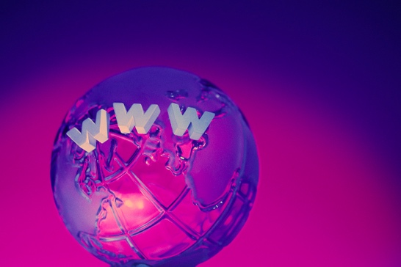
Figure 1. Figure captions are indented 5 spaces and justified. If you are familiar with Word styles, you can insert a field code called Seq figure which automatically numbers your figures.
s.greg.jones@narelab.com; phone 1 222 555-1234; fax 1 222 555-876; narelab.com
Table 2. Manuscript font sizes and formatting. This Microsoft Word template includes these formats as automated "styles,” which can be selected in the Format menu -- Styles and Formatting. (9pt)

Preformatted SPIE Template Styles

Manuscript component Description

SPIE paper title 16 pt. bold, center

SPIE authors/affiliations 12 pt., center
Keywords: *Keywords* 10 pt., left justify

SPIE ABSTRACT TITLE 11 pt. BOLD, center
SPIE abstract body text 10 pt., justify

SPIE SECTION HEADING 11 pt. BOLD, center, whole numbers
1.1 Heading 2, SPIE subsection heading 10 pt. bold, left justify, subsection numbers
SPIE body text 10 pt., justify
SPIE figure caption 9 pt., justify below figure
SPIE table caption 9 pt., justify above figure
SPIE footnote text 9 pt., justify, numbered
REFERENCE HEADING 11 pt. BOLD, center
1. SPIE reference listing 10 pt., justify, numbered in brackets

Mathematical Equations
Use common fonts like Times Roman in your math equations. A math reference in a paragraph sentence such as is not numbered. The steps of a mathematical argument can be numbered using a right-aligned tab for clarity, for example
α = (1)
and
ρ=. (2)

Tables and captions
Tables are centered. The caption goes above the table. The caption text should indent 5 spaces from left margin and justify. Table examples are on page 1 and 2 and below.
Table 3. Information on video and audio files that can accompany a manuscript submission.
Item | Video | Audio
File name | Video1, video2, … | Audio1, audio2, …
Number of files | 0-10 | 0-10
Size of each file | max. 5 mb | max. 5mb
File types accepted | .mpeg, .mov (Quicktime), .wmv | .wav, .mp3

Multimedia figures – video and audio files
Video and audio files can be included for publication. Table 3 lists the specifications for the mulitimedia files. Use a screenshot or another .jpg illustration for placement in the text. Use the file name to begin the caption. The text of the caption must end with the text "http://dx.doi.org/doi.number.goes.here" which tells the SPIE editor where to insert the hyperlink in the digital version of the manuscript.
Here is a sample illustration and caption for a multimedia file:
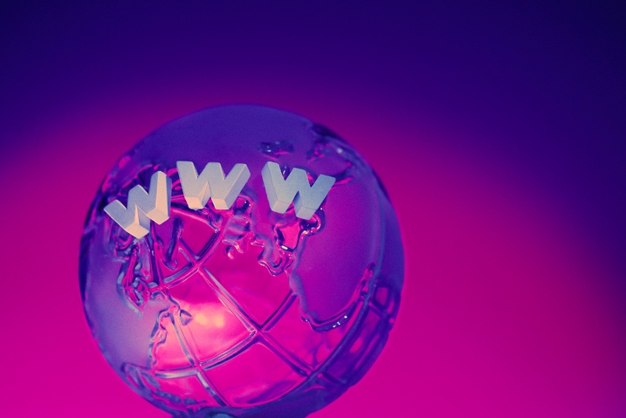
Video 2. A label of “Video/Audio 1, 2, …” should appear at the beginning of the caption to indicate to which multimedia file it is linked . Include this text at the end of the caption: http://dx.doi.org/doi.number.goes.here

using THIS TEMPLATE AND ITS Automatic formatting
This document template and more information is available on SPIE.org:
http://spie.org/x14101.xml or by emailing authorhelp@spie.org

References
- Booth, N. and Smith, A. S., [Infrared Detectors], Goodwin House Publishers, New York & Boston, 241-248 (1997).
- Davis, A. R., Bush, C., Harvey, J. C. and Foley, M. F., "Fresnel lenses in rear projection displays," SID Int. Symp. Digest Tech. Papers 32(1), 934-937 (2001).
- Van Derlofske, J. F., "Computer modeling of LED light pipe systems for uniform display illumination," Proc. SPIE 4445, 119-129 (2001).
- Myhrvold, N., “Confessions of a cybershaman,” Slate, 12 June 1997, <http://www.slate.com/CriticalMass/97-06-12/CriticalMass.asp> (19 October 1997). www.optics4yurresearch.com/7752.html
- Jones, C. J., Director, Miscellaneous Optics Corporation, interview, Sept. 23 2011
- FamilyName, GivenName Initial., "Title," Source, pg# (year).

