Abstract Template for META2025
[Bold, 14 point, Times or Times New Roman]

First Author ^{1,*}, Second Author ², and Third Author ^{1, 2}
[Auhor name(s): 10 pt, Times New Roman or Times, Name of the presenting author is underlined.]
ª Affiliation A, XXX University, Country
^{b} Affiliation B, Institute of YYY, Country
[Auhotr’s affiliation: Italic, 10 pt, Times New Roman or Time]
* Corresponding author: author@xxx.xxx.xxx

Authors are required to submit a ONE-page, camera-ready abstract, which may include figures and references. The abstract must be submitted via the OPIC website (https://opicon.jp/ja/submission/) in PDF format only. Each abstract submission must be accompanied by the author's online registration on the conference website.
The abstract should be formatted on A4-size paper with 2.5 cm margins on all sides. It should begin with the title, author names (with the presenting author underlined), affiliation, and the corresponding author's email address, all centered. Use 10 pt "Times New Roman," "Times," or equivalent fonts, except for the title, which should be in 14 pt boldface. The main text should be fully justified and single-spaced. The abstract, including equations, drawings, figures, and references, must not exceed one page.

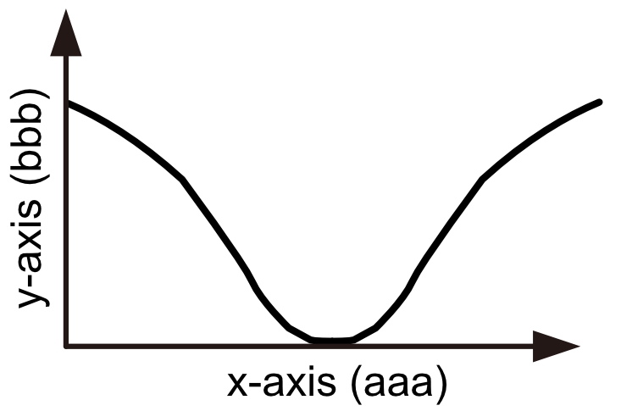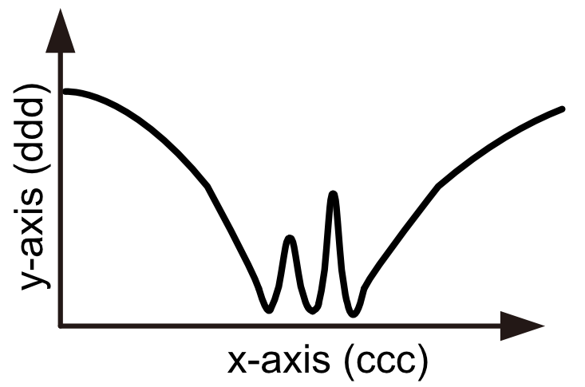
Figure 1. xxx. Figure 2. yyy.

The deadline of the abstract submission is December 18, 2024. The authors will be informed of the acceptance of their paper by e-mail. Poster presenters are required to pay the registration fee by the early bird registration deadline.

References
[1] X. Xxx, Y. Yyy, and Z. Zzz, Italicized Journal Name Volume number, page numbers (Year).
[2] X. Xxx, Y. Yyy, and Z. Zzz, Italicized Journal Name Volume number, page numbers (Year).

